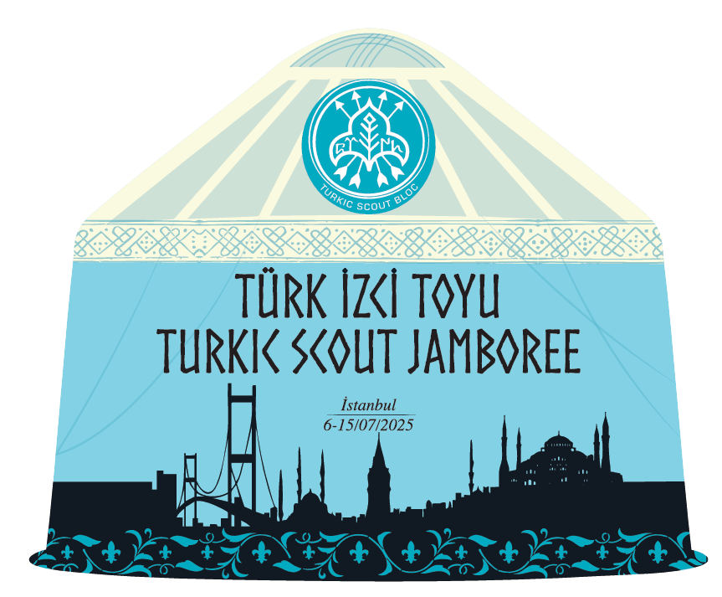
TURKIC SCOUT JAMBOREE
HANDBOOK

WHO YOU ARE ;
NAME-SURNAME

DATE OF BIRTH

CİTY | 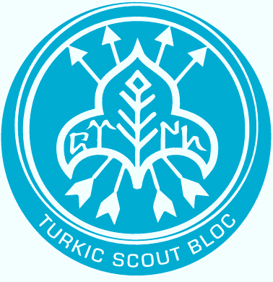
SCOUT UNIT

COUNRTY

PHONE NUMBER

MAİL ADRESS

SUB CAMP

WELCOME

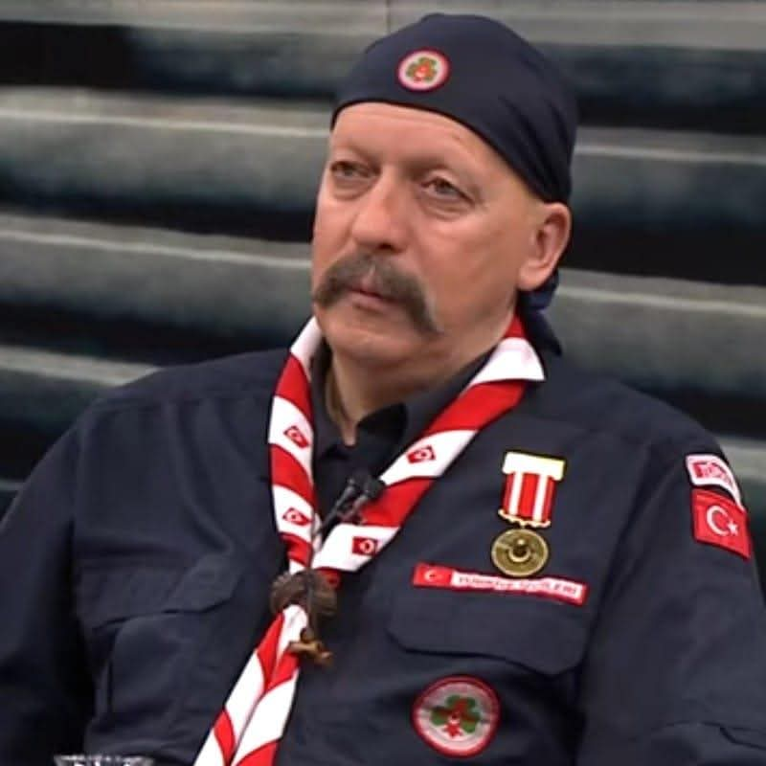
My Dear Brothers and Sisters in Scouting,
I greet you all with my heartfelt sentiments.
Congratulations on being members of the scouting family, where you can grow into healthy, happy individuals who make a positive difference in the world.
As you well know, a better, more beautiful, and peaceful world can only be achieved through the spirit of scouting.
By sharing these values with your fellow scouts around the world and the youth of your countries, you can become exemplary individuals who contribute positively to your communities.
Because societies take inspiration from disciplined and virtuous communities within them. Scouts will become friends and brothers, and their fellow citizens will follow their example..
When we established the Union of Turkic World Scouts and organized its camps, our goal was to strengthen the bonds between the Turkic world and related communities, and to encourage the exchange of knowledge and experiences. We also wanted to connect with scouts who see the Turks as friends and are curious about our hearts — and to truly feel and understand their cultures as well.
So, use this opportunity to build strong friendships throughout the camp.
Become cultural ambassadors who contribute to world peace.
Wishing you all joyful days filled with the spirit of scouting.
Allah protects those who work unity and solidarity
Allah may protect you.

HASAN DİNÇER SUBAŞI
CHİEF SCOUT OF TÜRKİYE

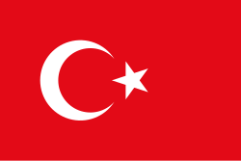  TÜRKİYE | 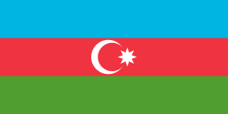  AZERBAIJAN |   HUNGARY
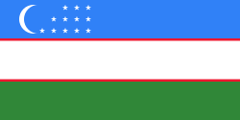  UZBEKISTAN | 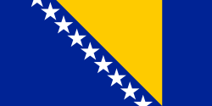  BOSNIA AND HERZEGOVİNYA | 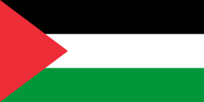  PALESTINE
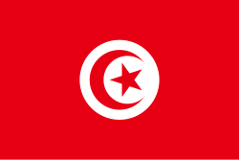  TUNISIA | 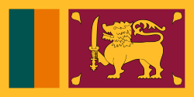  SRI LANKA | 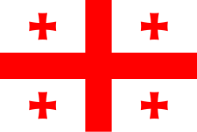  GEORGIA
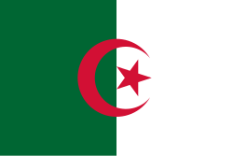  ALGERIA | 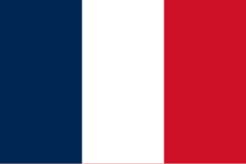  FRANCE | 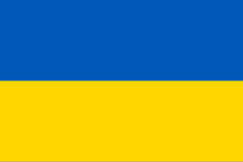  UKRAINE
BAYRAKLARLA KATILIMCI ÜLKELER

BAYRAKLARLA KATILIMCI ÜLKELER

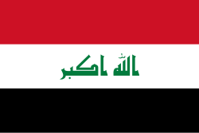  IRAQ | 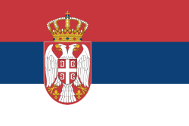  BURUNDI | 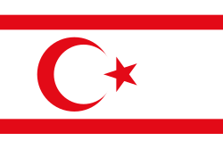  NORTHERN CYPRUS OF TURKEY
  QATAR | 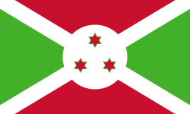  SERBIA | 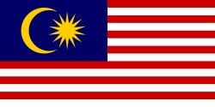  MALAYSIA
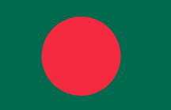  BANGLADESH |   YEMEN | 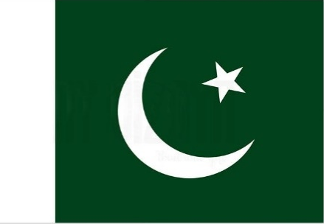  PAKISTAN

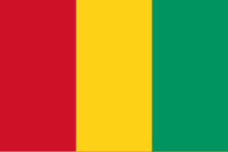  GENİYA |  | 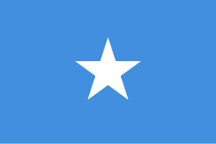

Let This Guide Lead the Way
Why should you keep this handbook with you?
In this book, you will find detailed information about the Turkic Scout Jamboree
We highly recommend that you read this handbook carefully to make the most of all the camp activities. You will also find important information about camp rules and emergency procedures here.
Most importantly, if you fill out the reward card located on the last page, you can receive your reward based on the activities you have participated in. Detailed explanations are provided on the reward card page..

IMPORTANT
PLEASE KEEP THIS HANDBOOK WITH YOU AT ALL TIMES.

DID YOU KNOW?
to the Turkic Scout Jamboree:
- Scouts from 20 countries
- 1000 scouts
- 100 supporting leaders and scout volunteers
will participate.

THE PURPOSE OF THE CAMP
To foster a spirit of unity, solidarity, friendship, brotherhood, and cooperation among the Turkic World and Related Communities.
At the same time, to engage in joint activities by communicating with scouts from all over the world, thereby contributing to world peace.
To maintain communication with scouts interested in Turkic culture.

The Republic of Turkiye
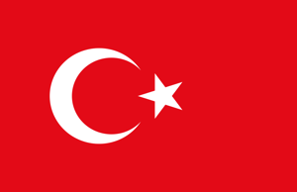

TÜRKİYE, The Republic of Turkey is a transcontinental nation, primarily located in Anatolia, with a smaller section in Trakya — the southeastern part of the Balkans. Turkey is uniquely located in four regions: Asia, Europe, the Middle East, and the Mediterranean.Thanks to its unique geographic position, Turkey has historically served as both a barrier and a bridge between two continents.

POPULATİON:91.000.000
AREA: 814.578 km2 (37th Largest Country in the World.)
GOVERNMENT TYPE: Democratic Constitutional Republic
CAPITAL: Ankara
OFFİCİAL LANGUAGE: Turkish
RELIGION: Approximately 99% of the population is muslim.
CURRENCY: Turkish LİRA, TL
COUNTRY CODE:TR
NUMBER OF PROVINCES:81
NEIGHBOR COUNTRIES: Turkey shares borders with Bulgaria and Greece to the northwest.
To the northeast, it borders Georgia, Armenia, Azerbaijan, and Iran.
To the south, it is bordered by Iraq and Syria.

GEOGRAPHICAL FEATURES:

Turkey is located at a geopolitically strategic point that connects Asia and Europe. The Bosporus and Dardanelles straits play a crucial role in transportation and trade between the two continents. Surrounded by seas on three sides, Turkey is a land of natural beauty, deep-rooted history, and rich culture, where all four seasons are experienced. Blessed with abundant natural resources both above and below ground, Turkey also benefits from a young, energetic, and well-educated population — one of its most powerful strengths alongside its strategic location.

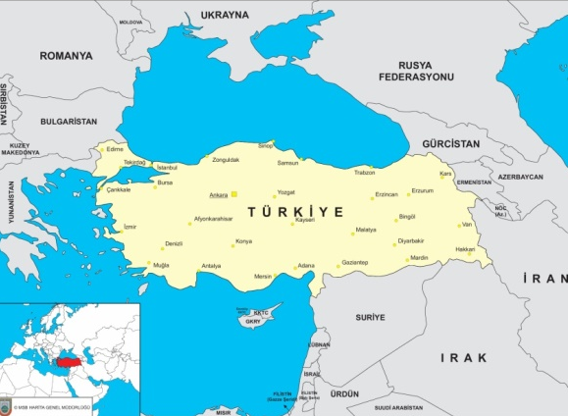
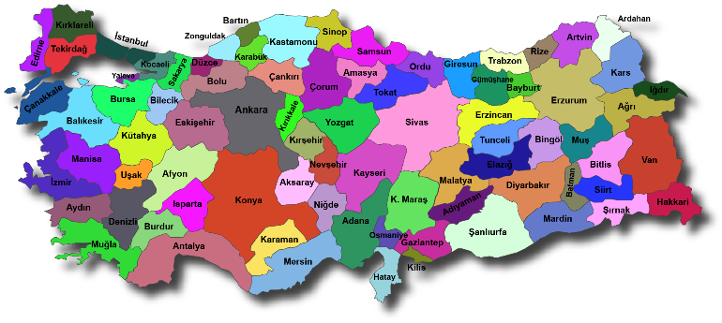

Istanbul: Capital of Three Empires
Istanbul is a megacity of immense historical and cultural value, known for its breathtaking natural beauty and rich collection of historical landmarks. It is the only city in the world that spans two continents—Asia and Europe—divided by a natural waterway. This unique geographical position, with a sea flowing through its heart, makes Istanbul truly one of a kind.
Throughout the ages, this strategic region—where land and sea embrace—has hosted numerous civilizations. Following its foundation, it quickly became a significant center of trade. The historic city of Istanbul is situated on a peninsula surrounded by the Sea of Marmara, the Bosphorus, and the Golden Horn. It is one of the rare cities that has consistently maintained its status as an economic hub throughout history. Istanbul holds a central position in both domestic and international trade.

One of the most striking aspects of Istanbul’s history is that it served as the capital of three great empires: the Roman, Byzantine, and Ottoman Empires. After being conquered by Sultan Mehmed the Conqueror in 1453, it remained the capital of the Ottoman Empire for 470 years, until 1923. During the Ottoman period, Istanbul became a center of science, culture, and the arts. It was also known for its remarkable atmosphere of tolerance, where mosques, synagogues, and churches coexisted side by side. Napoleon once said, “If the world were a single state, Istanbul would be its capital.”

Home to countless civilizations throughout the centuries, Istanbul stands as the economic, cultural, and historical heart of Turkey. With a population exceeding 15 million, it is the most populous city in the country—larger than 131 countries around the world.

The first historic landmark that comes to mind when thinking of Istanbul is, of course, Hagia Sophia. Originally built as a church, it was converted into a mosque after the conquest of Istanbul, later served as a museum, and since 2020 has functioned again as a mosque. Today, Hagia Sophia is not only one of Istanbul’s but also one of the world’s most significant historical symbols.
“Known as the "City of Seven Hills," Istanbul boasts numerous historic sites reflecting its rich heritage.
One of the world’s most important waterways, the Bosporus Strait, is a 29.9-kilometer-long channel that connects the Black Sea to the Sea of Marmara. For countries bordering the Black Sea such as Bulgaria, Georgia, Romania, and Ukraine, the Bosporus is the only maritime route to the Mediterranean Sea.
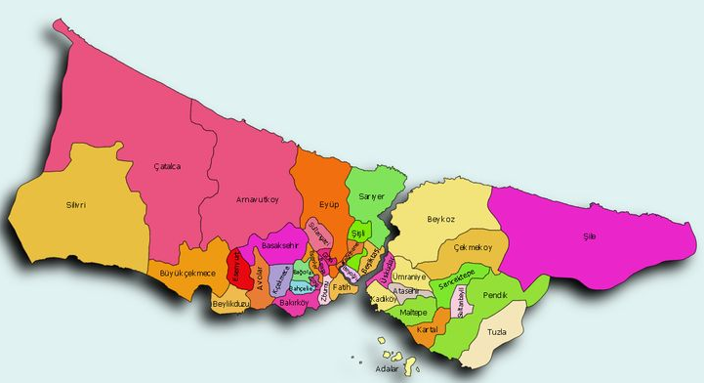
İstanbul is the biggest city of Türkiye and it is also 14th biggest city in the World
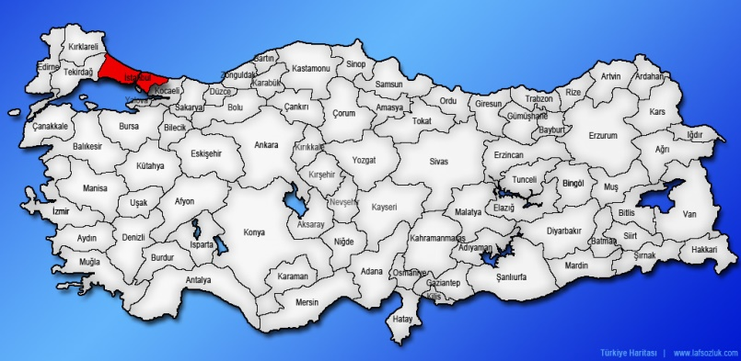
Date | WEATHER FORECAST |  | daytıme | Nıghttıme
Friday , July 4 | Sunny |  |  | 22°
Saturday , July 5 | Sunny |  | 32° | 21°
Sunday, July 6 | Sunny |  | 33° | 22°
Monday ,July 7 | Sunny |  | 34° | 23°
Tuesday July 8 | Sunny |  | 33° | 23°
Wednesday,July 9 | Sunny and Windy |  | 34° | 23°
Thursday , July 10 | Mostly Cloudy ve Windy |  | 26° | 21°
Friday , July 11 | Mostly Cloudy |  | 25° | 21°
Saturday , July ,12 | Sunny |  | 29° | 21°
Sunday , July 13 | Sunny |  | 32° | 21°
Monday , July 14 | Sunny |  | 33° | 23°
Tuesday , July 15 | Sunny and Windy |  | 33° | 23°
Wednesday ,July 16 | Sunny and Windy |  | 33° | 22°
Thursday , July 17 | Sunny |  | 34° | 23°
Friday , July 18 | Sunny |  | 35° | 24°
Saturday , July 19 | Mostly Sunny |  | 28° | 22°
İSTANBUL WEATHER FORECAST

TURKIC SCOUT BLOG
The Turkic Scout Blog was officially established on December 8, 2024, in Baku, the capital of Azerbaijan. This historic initiative brought together the National Scout Organizations (NSOs) of Azerbaijan, Hungary, Kazakhstan, and Türkiye as founding members, with Uzbekistan and Kyrgyzstan participating as observers.

The Turkic Scout Bloc was founded by the National Scouting Organizations of Azerbaijan, Hungary, Kazakhstan, and Turkey to support the development of scouting, strengthen cooperation, and deepen friendships among the member and observer countries of the Organization of Turkic States (OTS), as well as among countries with Turkic origins and/or heritage, all in the spirit of unity and shared values..

The establishment of the Turkic States Scouting Organization aligns with the vision of the Organization of Turkic States to promote cooperation among countries with a common heritage and history. The organization brings together NSOs from OTS member and observer countries to foster strong bonds among youth based on shared traditions and values.

Three strategic priorities of the Turkic States Scouting Organization have been outlined:
- Turkic Scout Emblem Program: A unified one-year program designed to help youth and children in member and observer countries develop their skills, leadership, and scouting values.
- Turkic Scout Jamboree: A regional scouting camp where scouts from member and observer countries come together to build friendships, promote unity, and participate in a joint jamboree program.
- Support for Emerging NSOs: Efforts to strengthen and promote the scouting movement in Uzbekistan and Kyrgyzstan, with plans to expand to include Turkmenistan in the future.

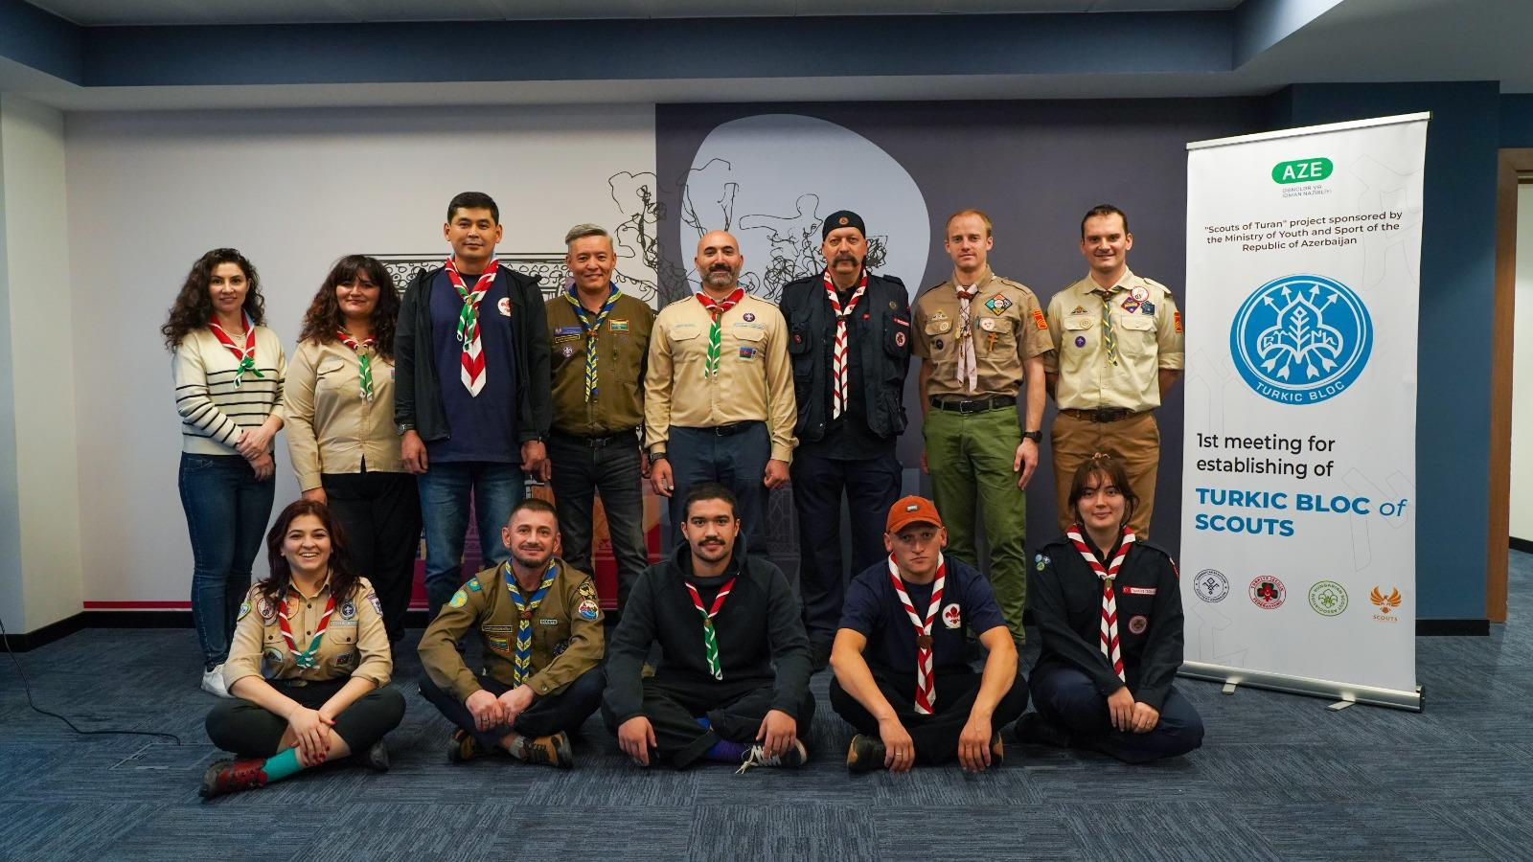
Through these initiatives, the Turkic States Scouting Organization aims to connect young people and build a strong network of future leaders based on the values of unity, cultural exchange, and cooperation that embody the spirit of the Organization of Turkic States.

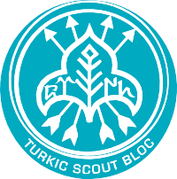
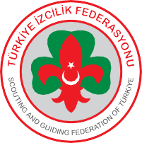










07:00 – Wake-up for the Duty Patrol
07:30 – Waking Up
08:00 – Breakfast
09:00 – Checking the patrols
10:00 – Flag Ceremony
11:00 – 12:00 – Activity
12:30 – Lunch
14:30 – 15:30 – Activity
16:00 – 17:00 – Activity
17:00 – 17:30 – Afternoon Snack
17:30 – 18:30 – Activity
19:00 – Dinner
20:30 – Campfire Preparation
21:00 – Campfire
23:00 – Bedtime Preparation
23:30 – Silence in the Camp

ACTIVITIES
Activities of Turkic Scout Jamboree
ACTİVİTİES:
- Traditional Archery
- Archtec Game
- Ebru (Turkish Marbling Art)
- Orienteering
- Climbing
- Game Station
- Swimming Pool
- Badminton
- Rhythm
- Hiking
- Cultural Exchange
- Language Drill
- Rope Game
- Music
- Knots
- Experiencing traditional games and cultural activities at each nation's country
- International Day
TOURS: HISTORICAL AND CULTURAL SITES OF ISTANBUL
- Hagia Sophia Mosque
- Sultanahmet
- Grand Bazaar
- Spice Bazaar
- Eyüp Sultan Mosque
- Topkapı Palace
- Çamlıca Mosque
- Shopping Day

Tours:
Participants will take trips to Istanbul’s cultural and historical sites during their designated days. These excursions will offer a chance to delve deep into history once again.
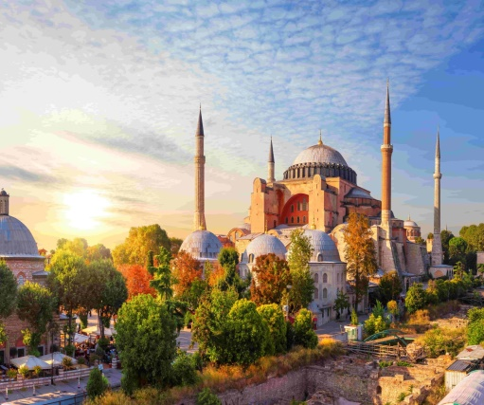
HAGIA SOPHIA
Located directly opposite the Sultanahmet Mosque, Hagia Sophia was built between 532 and 537 by Byzantine Emperor Justinian I in the historic peninsula’s old city center. After Istanbul was conquered by Sultan Mehmed the Conqueror in 1453, this historic monument was converted into a mosque. Following the proclamation of the Republic, part of it was used as a museum, and it currently serves as a mosque.
The name Hagia Sophia means “Holy Wisdom” and it is listed as a UNESCO World Heritage Site. It has been used as a basilica, cathedral, museum, and mosque.

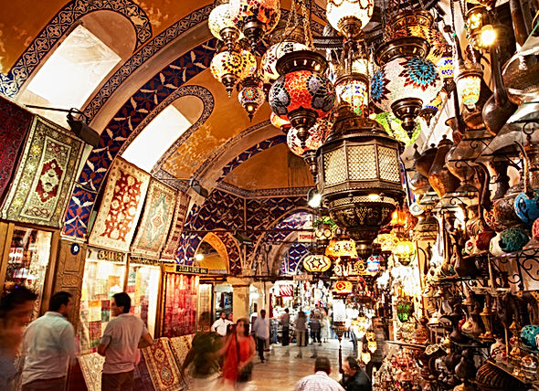
GRAND BAZAAR
Known as the world’s first shopping mall, the Grand Bazaar is one of the top attractions in the Istanbul region. Housing approximately 4,000 shops, it is the oldest and largest covered market in the world.
Thought to date back to the Byzantine era, the Grand Bazaar was ranked the most visited tourist attraction worldwide in 2014. The massive labyrinthine structure is impressive in appearance.

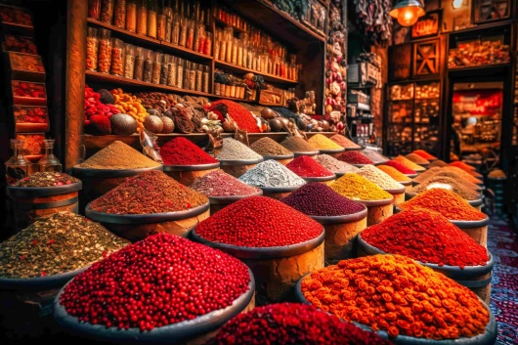
SPICE BAZAAR EMİNÖNÜ
One of Istanbul’s oldest covered bazaars, the Spice Bazaar is famous for its herbalists. Along with natural remedies, spices, flower seeds, and rare plant roots and barks, the bazaar also sells dried fruits and delicatessen products. The Spice Bazaar is open every day of the week and contains 100 shops and 2 restaurants.

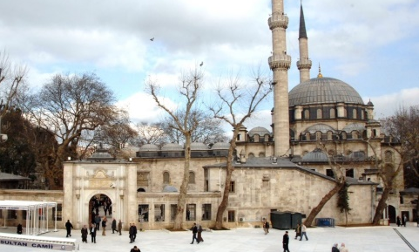
EYÜP SULTAN MOSQUE, EYÜPSULTAN
Located opposite the Eyüp Sultan Tomb, Eyüp Sultan Mosque is part of the Eyüp Sultan Complex. Situated on the shores of the Golden Horn, the Eyüp Sultan Tomb is a sacred pilgrimage site traditionally visited by Ottoman sultans before military campaigns. The tomb also houses the grave of the poet Ahmet Haşim

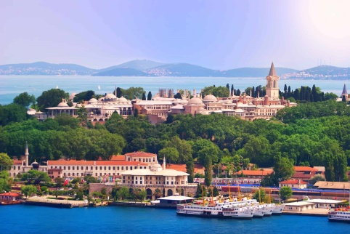
TOPKAPI PALACE
Built by Sultan Mehmed the Conqueror after the conquest of Istanbul, Topkapi Palace is one of the must-see places in Istanbul. Listed as a UNESCO World Heritage Site in 1985, it stands as the most important monument within the Historic Peninsula of Istanbul.

ÇAMLICA MOSQUE
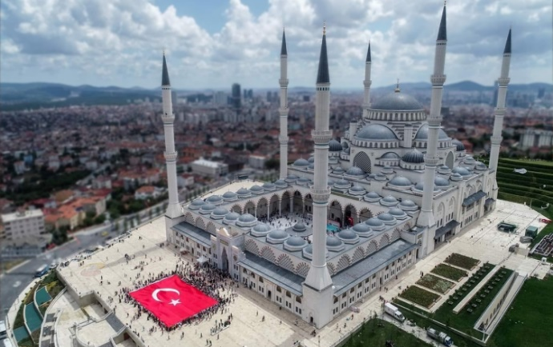
As Turkey’s largest mosque, Çamlıca Mosque can be seen from every point in Istanbul. It has the capacity to accommodate 63,000 worshippers at once, with a main dome 34 meters in diameter. Its architecture blends Ottoman-Seljuk and contemporary styles.
The mosque’s four minarets with three balconies each are dedicated to the Battle of Malazgirt and stand 1071 meters tall, while the two minarets with two balconies each reach 90 meters in height. The main dome, standing 72 meters high, symbolizes the 72 nations living in Istanbul, and the 34-meter diameter dome represents the city itself..

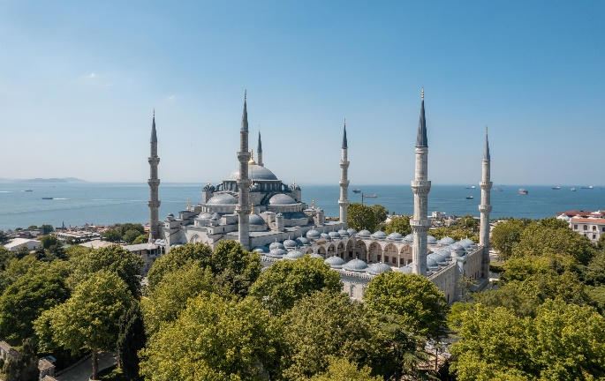
SULTANAHMET MOSQUE
One of Istanbul’s most iconic landmarks, Sultanahmet Mosque captivates visitors with its grandeur and history. As one of the finest examples of Ottoman architecture, it has adorned the city’s skyline for centuries.
Located in the historic city center, this unique structure impresses visitors with its architectural details and rich cultural heritage.

CAMP RULES
1. Assign your scout units to your sub camp area.
2. When placing scouts in tents, pay attention to gender, age groups if applicable, and disability status. Arrange scouts so that at least three stay in each tent. Scouts and leaders cannot share the same tent.
3. Assign 3 leaders or scout volunteers to manage and organize food services in your sub camp.
4. Establish and operate a nightshift system in your sub camp area.
5. Each side camp will use the designated toilets and bathrooms given to them specifically.
6. Set up a duty for cleaning the toilets and bathrooms that you are given
7. Request necessary cleaning supplies for toilets and bathrooms from the responsible personnel..
8. Charging devices in restrooms is not allowed
9. Do not allow scouts to use their phones during activities or breaks..
10. Leaders should use the charging unit located at the camp center.
11. NEVER light a fire anywhere in the camp!
12.Make a announcement board in a visible spot in your subcamp by using natural materials
13. Ensure that all groups in your sub camp are informed of all activity-related announcements.
14. Scouts cannot move alone or go anywhere without their leader’s and camp management’s knowledge.
15. Each side camp must establish its own nightshift system according to instructions and ensure the watches are properly maintained.
16. Leaders and scout volunteers assigned to the support team are not allowed to enter scout camping areas unless it is part of their assigned duties.
17. The camp file given to side camp management must be filled out completely and submitted to the management at the end of the camp.
18. Inform camp management about scouts and leaders with gluten or lactose allergies or who are vegetarian.
19. Camp security during the camp will be provided by TİFAKE and Supporter Leaders.
20. Immediately report any suspected danger inside the camp to camp management.
21. Each side camp will be equipped with adequate fire suppression equipment. Make sure assigned personnel are trained to operate it in case of emergency.
22. Smoking is strictly prohibited outside the designated smoking areas in the camp. Leaders who smoke may do so only in the assigned area. Scouts are NEVER allowed to smoke or use similar substances.
23. Alcoholic beverages are prohibited inside the camp. Bringing alcohol into the camp from outside is strictly forbidden.
24. Separate your waste (glass, metal, food, paper) according to the schedule and bring it to the designated waste center. Do not litter.
25. The Camp Health Center is located opposite the campfire area. If a scout falls ill or gets injured, first inform their leader and then go to the health center together.
26. If any scouts need medication that requires refrigeration, label the medicine with the scout’s name, country/province, and your phone number before handing it over to the health center .
27. Check the lost and found box at the center for any lost items. Turn in any found items to the staff to be placed there.
28. Each side camp must allocate a space for religious purposes.
29. To avoid health problems, pay attention to your sleep, follow hygiene rules, and maintain personal cleanliness for both yourself and your scouts.
30. Throughout the camp, scouts, leaders, volunteers, and support teams must wear their uniforms and camp t-shirts.
31. Always wear your camp scarf and ID card.
32. Our Media Team will be filming continuously during the camp. To avoid poor impressions especially during flag ceremonies, do not record individuals with your phone. Media footage will be shared with you.
33. You can get drinking water from the water points in your sub camp area.
34. Meals will be served in the camp dining hall. Side camps will eat in the designated areas announced and are responsible for cleaning their tables. After meals, all scouts and leaders must wash their dishes in the dishwashing area..
35. The campfire program will be held every evening at the designated campfire area in the camp center. No random music broadcasts are allowed elsewhere that may disturb scouts.
36. Flag ceremony will take place daily at 10:00 AM at the ceremony area in the camp center. Attend on time and in uniform. Attendance is mandatory.
37. To keep the food fresh, items brought for Countries Day should be labeled with your information and handed over to the kitchen.
38. The designated area will host the Countries Day event. Necessary materials can be obtained from camp staff upon request.

39. The scout shop will open at specified times where scout supplies can be purchased.
40. Countries and groups are welcome to exchange scout souvenirs or supplies as a gesture of friendship. Please note that trades are limited to small, low-value scout items, must be conducted only in the designated trading area, and trading between adults and scouts is not permitted. Exchanges outside of the designated area are strictly prohibited.
41. After the hours specified in the camp program, no scouts, leaders, or support staff are allowed to roam the camp or make disruptive noises. Night shifters will remind you of this. Full silence is expected from everyone.
42. At the entrance, all groups and countries are required to collect their ID cards, camp scarves, shirts, and memory badges.
43. Participation in the activities and properly filling out the reward cards is essential for scouts to earn their awards—please provide support and encouragement.

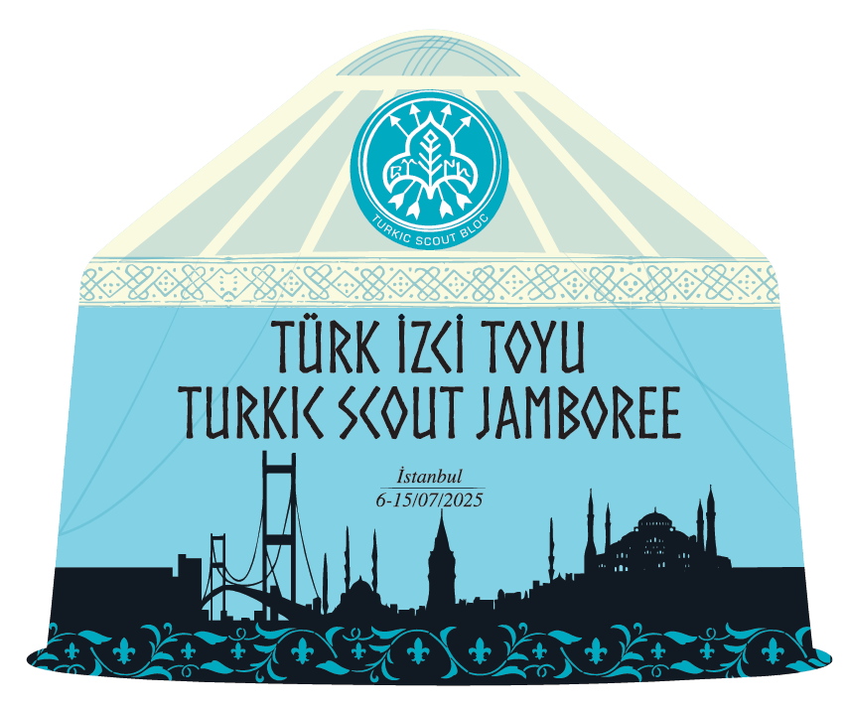

TURKIC SCOUT BADGE
The badge of the Turkic World and Related Communities International Camp is designed in the shape of a "Otağ." The term "Otağ" refers to a traditional Turkic tent or tent-like dwelling, commonly used by Turks and other Central Asian communities. It is a term for the tent used by a family or community living together. The emblem symbolizes the unity and togetherness of Turkic and related communities.
Inside the Otağ is the emblem of the Turkic Scout Blog, which represents the coming together of countries with a shared heritage and history to promote cooperation and build strong bonds among youth based on common traditions and values.
Since the Turkic World and Related Communities Jamboree is held in Istanbul, the badge also features landmarks symbolizing the city.
TURKIC SCOUT JAMBOREE FULARS
At the Turkic Scout Jamboree, there are many people in various roles—from scouts to camp management and support teams. Different scarf colors are used to help identify everyone’s role clearly..


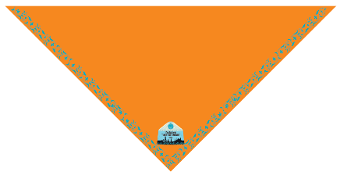
STAFF LEADER SCOUT

AWARD CARD
Dear Scouts, when you participate in the stations, please have your reward card stamped by the activity leader.
** Take part in the first three activities and collect stamps.
ORIENTEERING
T.ARCHERY
CLIMBING
Award

** Take part in the six activities and collect stamps.
ARCHTEC GAME
GAMES
RHYTHM

Award

** Attend all activities and have your card stamped..
BADMINTON
POOL
MARBELİNG ART
Award

Keep your handbook with you in order to receive your award.

MY 10 NEW FRIENDS IN SCOUTING
1 | NAME-SURNAME: | COUNTRY:  DATE:  MAİL:
2 | NAME-SURNAME: | COUNTRY:  DATE:  MAİL:
3 | NAME-SURNAME: | COUNTRY:  DATE:  MAİL:
4 | NAME-SURNAME: | COUNTRY:  DATE:  MAİL:
5 | NAME-SURNAME: | COUNTRY:  DATE:  MAİL:
6 | NAME-SURNAME: | COUNTRY:  DATE:  MAİL:
7 | NAME-SURNAME: | COUNTRY:  DATE:  MAİL:
8 | NAME-SURNAME: | COUNTRY:  DATE:  MAİL:
9 | NAME-SURNAME: | COUNTRY:  DATE:  MAİL:
10 | NAME-SURNAME: | COUNTRY:  DATE:  MAİL:

